Name: Diana Zhao Date: 2/11/2024

NYU ID: dz1371

Course Section: 8669

Lab 2

Total in points (100 points total):

Professor’s Comments:

Affirmation of my independent effort: Diana Zhao

1. Google chrome; request to http://youtube.com

a. 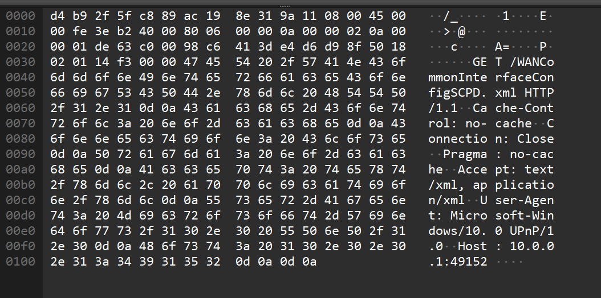

b. [Full request URI: http://10.0.0.1:49152/WANCommonInterfaceConfigSCPD.xml]

HTTP v1.1 for request and response

User-Agent: Microsoft-Windows/10.0 UPnP/1.0\r\n

SERVER: Linux/5.4.155-prod-22.2, UPnP/1.0, Portable SDK for UPnP devices/1.6.22\r\n

c. HTTP1.1 connections are persistent.

d. The server needs to know the browser type to set up the connection; web browser is google chrome

e. successful; XML document

f.

2. Docker

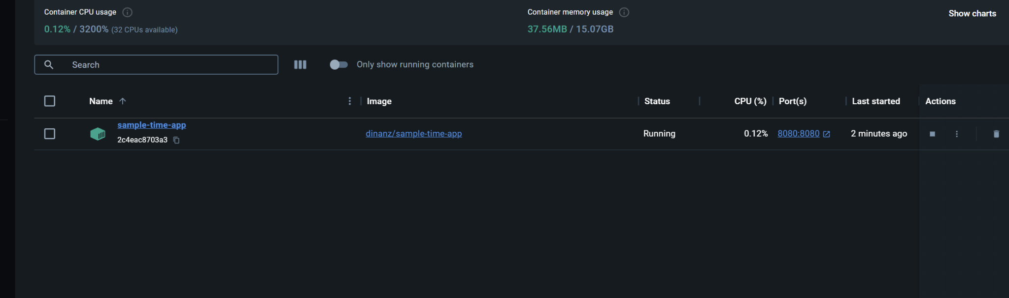

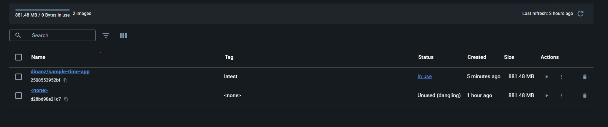

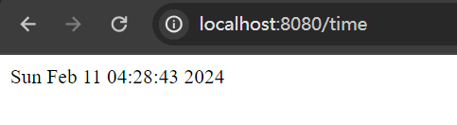

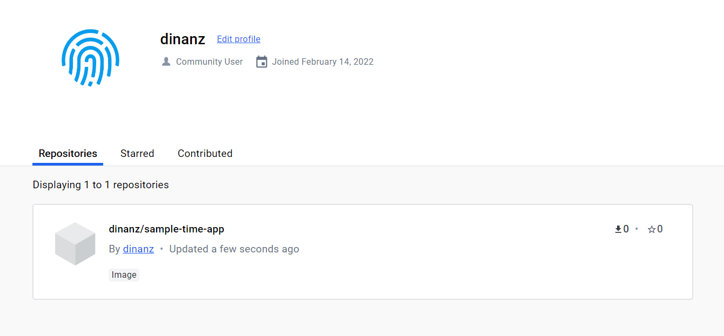

https://github.com/dinanz/nyu-cs2262-001-fa20